**TASK 6: RAG Implementation**

1. Upload knowledgebase via pdf file and store it in Qdrant vector DB. Here the file is picked from resource folder on calling the endpoint. This can be extended to accept a pdf file as well.

1. Collection created in Qdrant.

1. Data from file is stored in Qdrant.

1. Querying the information endpoint to get data.

Observation: When sent a query with the solution not in the knowledgebase we uploaded in Step 1, the service returns that the provided knowledgebase does not contain information related to it.

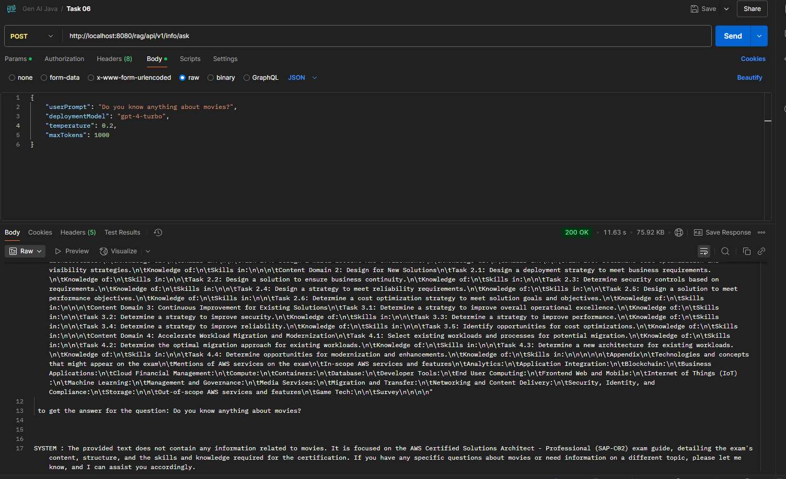

1. When querying about information present in the knowledgebase, it provides a well formatted complete response with all details separated by sections explaining who this exam is for, overview, exam format, skills covered, etc. Its not simply a dump of uploaded data, but returns a summary of it in well-structured and user friendly manner.

